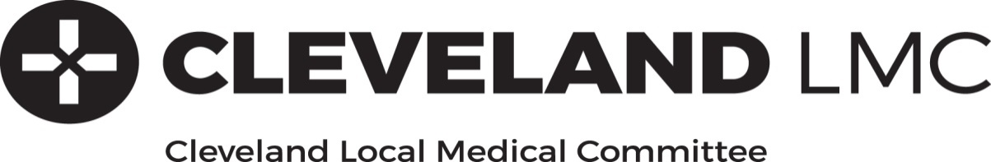

Re: Coronavirus and requests for Doctor’s Notes (Med3/Fit Note)

Requests for certification of absence from the workplace may fall into five categories:

1. Personally affected so isolating for seven days
2. Personally affected and remaining unwell for over seven days
3. Household contact affected so isolating for fourteen days as per government advice
4. At risk group so following government advice
5. Those in full time education.

1. Personally affected so isolating for seven days
Patients can and should self-certify for the first seven days as normal if they are unfit to work.

They do not need to contact their GP.

2. Personally affected and remaining unwell for over seven days
If they remain unwell and unfit to work after seven days the current advice is to visit www.111.nhs.uk where there is an online self-assessment tool; the patient may be invited to call 111 and given further advice and a MED3 certificate emailed to them.

They do not need to contact their GP.

3. Household contact affected so isolating for fourteen days as per government advice
4. At risk group so following government advice
GPs cannot and are not the gatekeeper of the statutory sick pay system. Employers are responsible for putting in place arrangements for home/remote working where this is possible. Where it is not, the employee may self-certify and return to work following the relevant absence which their employer may authorise as per government advice. Where they do become unwell during or after this time, point 1 and 2 applies.

They do not need to contact their GP.

5. Those in full time education.
There is no NHS requirement to issue certification to schools or colleges to confirm absence. These organisations must work with parents and students to ensure that any absence is appropriately recorded, obviating the need for a ‘doctor’s note’.

They do not need to contact their GP.

As per the current www.gov.uk S13 Guidance for Employers it should be noted that:

“By law, medical evidence is not required for the first 7 days of sickness. After 7 days, it is for the employer to determine what evidence they require, if any, from the employee. This does not need to be a fit note (MED3) issued by a GP or any other doctor.

“Your employee will be advised to isolate themselves and not to work in contact with other people by NHS 111 or Public Health England if they are a carrier of, or have been in contact with, an infectious or contagious disease, such as Covid-19.

“We strongly suggest that employers use their discretion around the need for medical evidence for a period of absence where an employee is advised to stay at home due to suspected Covid-19, in accordance with the public health advice being issued by the government.

This note has been written for and on behalf of your surgery by Cleveland LMC, the body in statute that represents, supports and advises Cleveland GPs and their practice teams.

Our GPs have a responsibility to prioritise the assessment and management of the needs of their patients at this challenging time, we thank you for your support in helping us achieve this.

Yours sincerely

